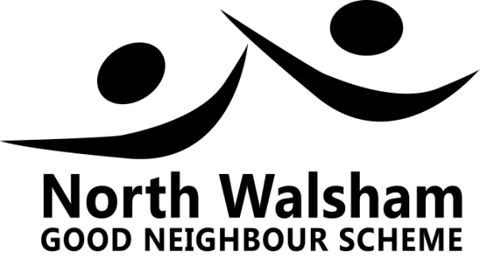
Feedback and Donations Policy

If you have any feedback you wish to give us, either good or bad, we would be pleased to hear from you.

We are always striving to improve the quality, range and speed of the service we provide to our neighbours in North Walsham, within the constraints of being a volunteer run organisation.

We aim to treat everyone with dignity and respect and be friendly and professional in the way we do things.

If you have any comments you wish to make about the service you have received please feed this back to us, either by:

- Telephoning the Chair, Peter Tobitt, on 01692 406016; or,

- Leaving a comment under the Review tab of the Scheme’s website on www.nwgoodneighbour.org.uk

Our Scheme, which is run exclusively by local volunteers, has to raise funds to cover necessary expenses e.g. telephone; website; insurance; administration and publicity.

If you feel inclined to make a donation towards these costs, it would be much appreciated. You can make a donation directly to the Treasurer (Paul Robinson on 01692 407655) or by using the Donate tab on the Scheme’s website - www.nwgoodneighbour.org.uk

Thank you.

